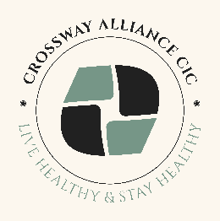
CROSSWAY ALLIANCE CIC
OUR DELIVERY MODEL & SOCIAL VALUE
Crossway Alliance delivery model includes the cross-sector partnership with VCSFE within Heywood and Rochdale, Social Prescribers, Local services.
We are an existing provider of the health promotion and community health education services in Rochdale Borough and by using our expertise Crossway Alliance can ensure the service elements are fulfilled by workforce with proven skills and experience and in the sector and borough.
Social Value
At Crossway Alliance we demonstrate our commitment with the following:
- Crossway Alliance is confident in meeting the Charter for Employment Standards, and Rochdale’s Social Value Pledge. Crossway Alliance will sign up to the Charter and agree social value outcomes.

- Crossway Alliance will ensure that all partners already pay staff above the living wage.

- Crossway Alliance has a history of delivering social value within Rochdale having been founded by local resident through community engagement, and intrinsically growing through the goodwill and utilisation of community- based assets.

- Crossway Alliance has a record of challenging anti-discriminative practice and stigma and bringing people within communities closer together through their advocacy, campaigning, training and partnership working.

- Crossway Alliance will offer advice, guidance and support to adults through professionals experienced in working with people from diverse backgrounds.

- Crossway Alliance as a community interest company is injecting funds into the local economy from external funding which directly benefits Rochdale Borough residents. This level of external income generation is expected to continue.

- Crossway Alliance will offer high quality, supported volunteering opportunities to local people. The project will include training and support aimed at upskilling and offering work-based experience to increase employability. 5 volunteers are currently active, the majority of whom live within Rochdale Borough.

- Crossway Alliance aims to employ over 5 staff, the majority of whom live within Rochdale. This provides full-time, part-time, job shares and sessional employment for local residents.

- Crossway Alliance CIC is committed to embedding our Environmental Policy, which sets out expectations on reuse and recycling, water and energy efficiency, purchasing environmentally friendly products and services, use of local suppliers and use of public transport systems.

- Crossway Alliance CIC expects to continue to receive “in kind” support such as food and monetary donations and in the future to offer student placements.

- Additional Social Value benefit from contracts award to Crossway Alliance CIC is that we will maintain services and staffing in Rochdale along with the same accessibility for Rochdale residents.

